# FitPage Backend Assignment

1. Add Location:  
   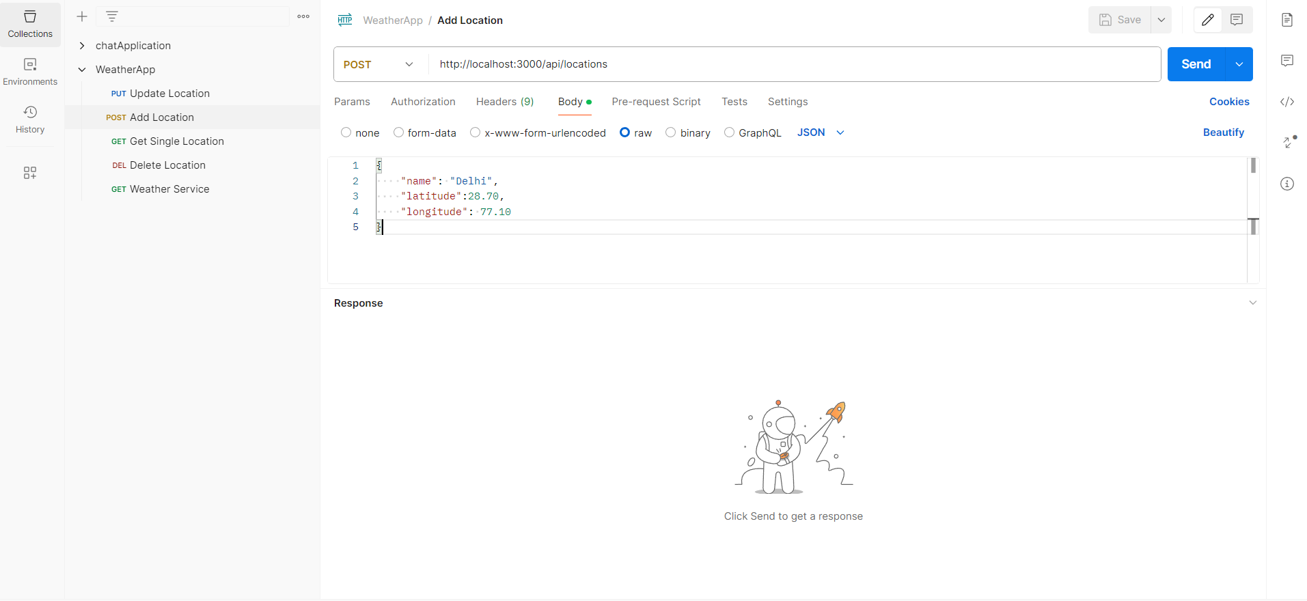
2. Get Single Location  
   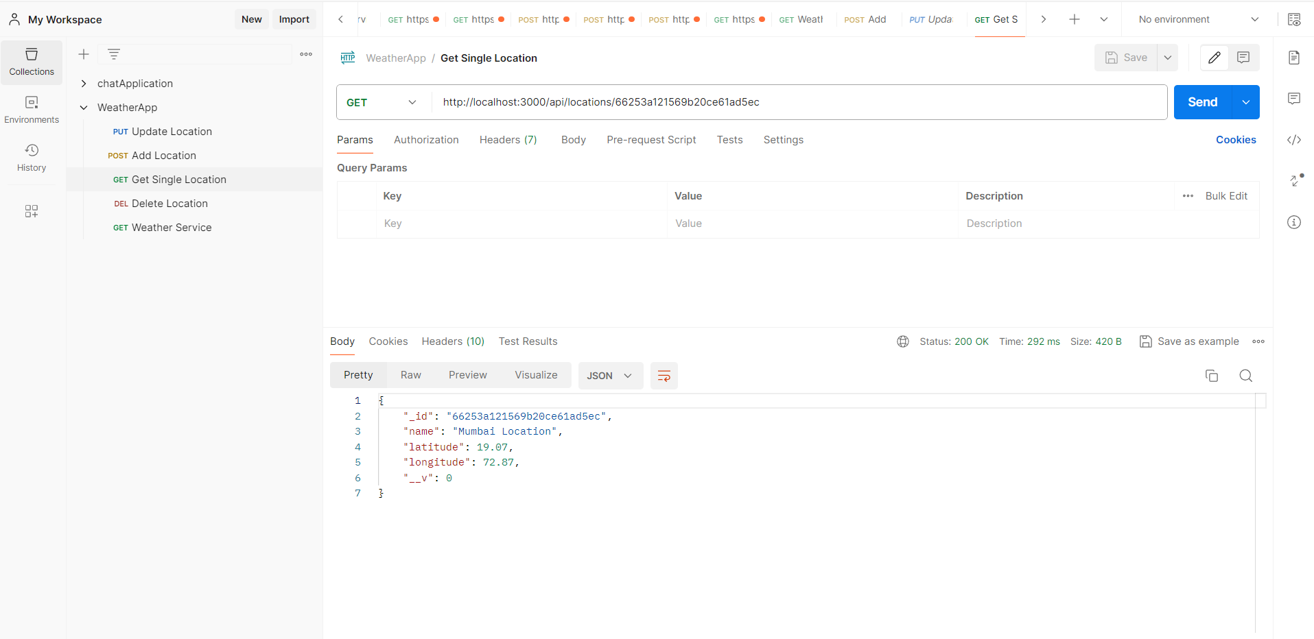
3. Update Location  
   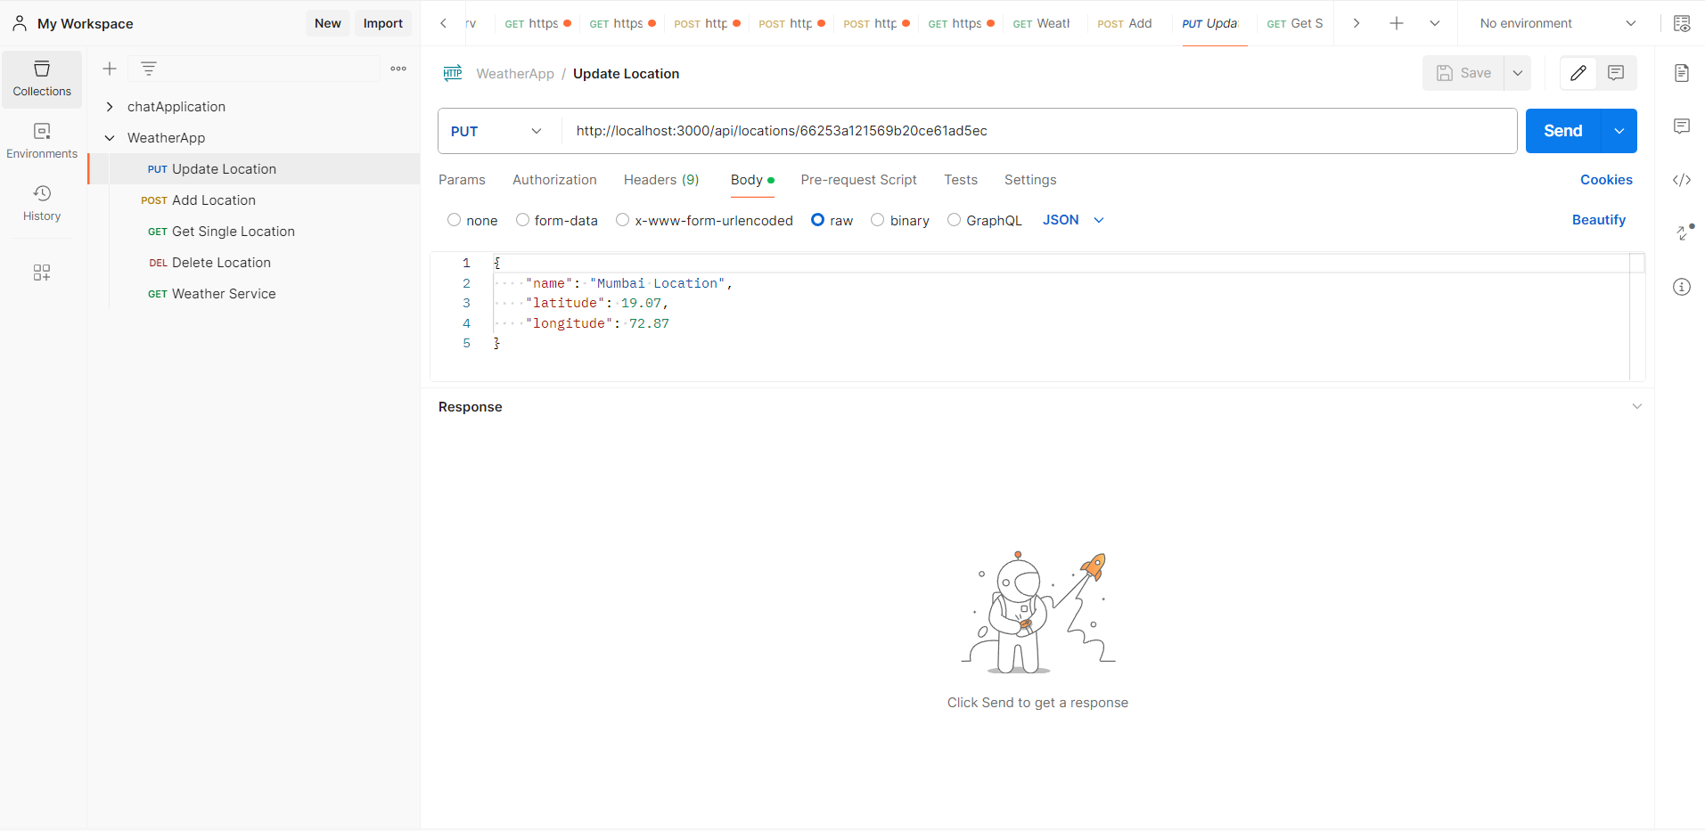
4. Delete Location  
   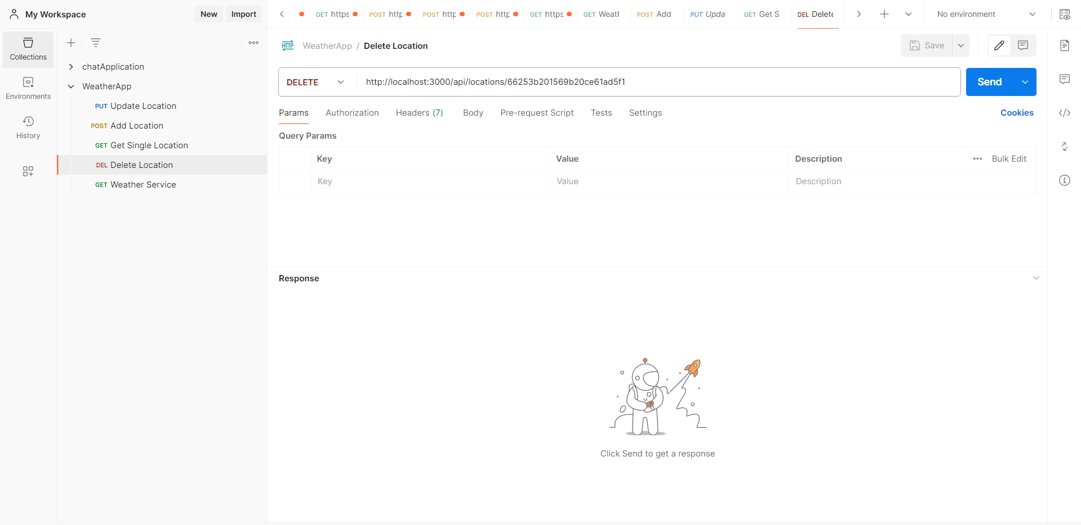
5. Weather Services  
   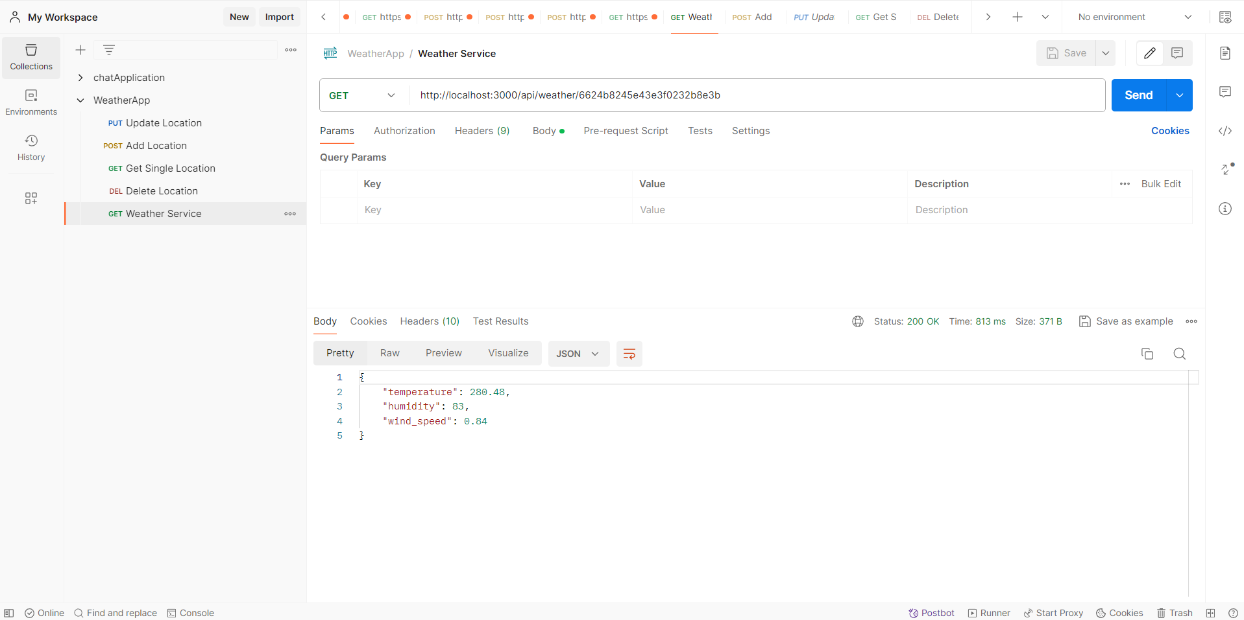
6. 6. Weather History: This feature was not implemented in the project due to the requirement of a paid subscription for the external API. However, implementing the history feature should not be difficult.

# External APIs and Tools Utilized:

## Description:

For this project, we utilized external APIs and various tools to enhance functionality and streamline development. We integrated the OpenWeather API (https://home.openweathermap.org/) to retrieve weather data and employed Node.js along with MongoDB as our primary development tools. These technologies enabled us to efficiently gather and process weather information, contributing to the overall success of the project.